*Florida International University*

*School of Computing and Information Sciences*

CIS 4911 - Senior Capstone Project

Software Engineering Focus

Feature Document

User Story #806 Get a response from Body Basics.

**Team Member:**

Alexander Karpis

**Product Owner(s)**:

Francisco Ortega

**Mentor(s)**:

Francisco Ortega

**Instructor**: Masoud Sadjadi

**User Story**

* As a Team Developer I would like to better understand the Body Basics sample so I can get a response from the Kinect for painting.
* Set up the Body Basics and comprehend the program.
* Manipulate the program to provide coordinate positions of a given part of the body.

**Acceptance Criteria**

* Body Basics put into an empty project and able to run.
* Being able to explain parts of the program.
* Get a response from the program.

**Use Case** #**1 Get coordinates from the Kinect gesture.**

The users will be able to get a response from the Kinect with a gesture.

Actors: User.

Entry Condition:

This use case start when:

* The user does a given gesture at the Kinect.

Flow of events:

1. The user performs a given gesture at the Kinect.

2. The system processes the gesture.

3. The system provides a response to the gesture.

Exit Condition:

The response has been given to the gesture.

**Use Case Diagram**

NA

**Sequence Diagram**

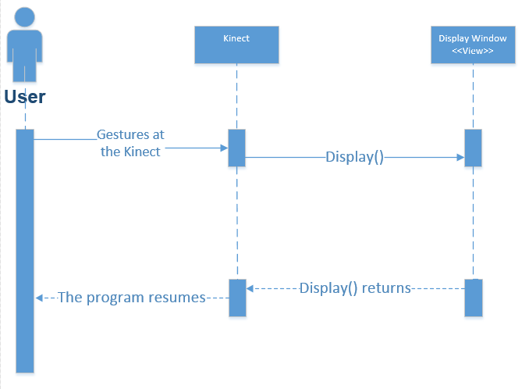

**Class Diagram**

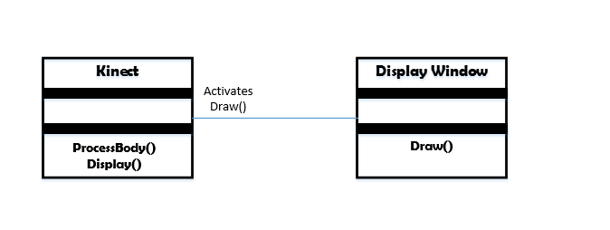

**Unit Test**

Sunny Day Tests

Test Case: Output from Body Basics

Test Purpose: Ensure that user can get a response from Body Basics..

Test Setup:

⦁ run program

Test Output:

Coordinates of the hands within a range.

Expected Output:

After testing, coordinates should be printed to an output file.

**Integration Test**

After reducing some of the code in Body Basics and moving to an empty project, and adjusting the range, Body Basics produces expected results.

**Visual User Guide - 3 pages**

1. **The user starts with the body basics program running and hands open.**

**If the user’s hands are open, it will be indicated by a green circle around their hands.**

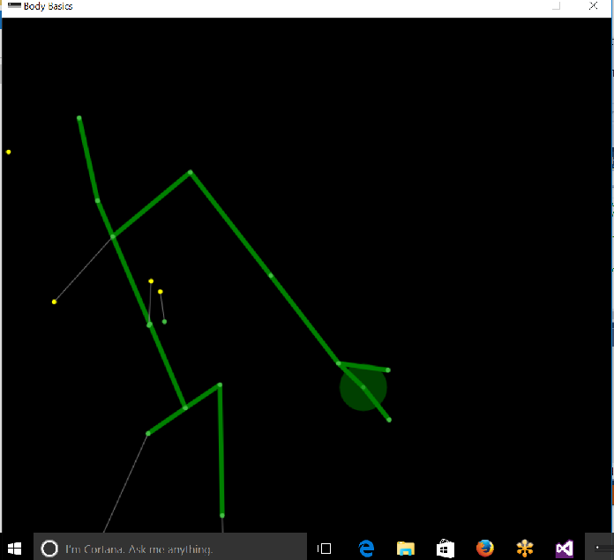

**2. The user closes their hands and the green circle should be red now in the Body Basics program window.**

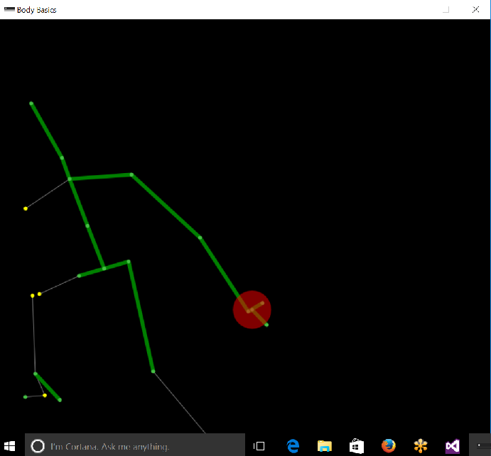

**3. Due to my code, the output should be printed to a file.**

